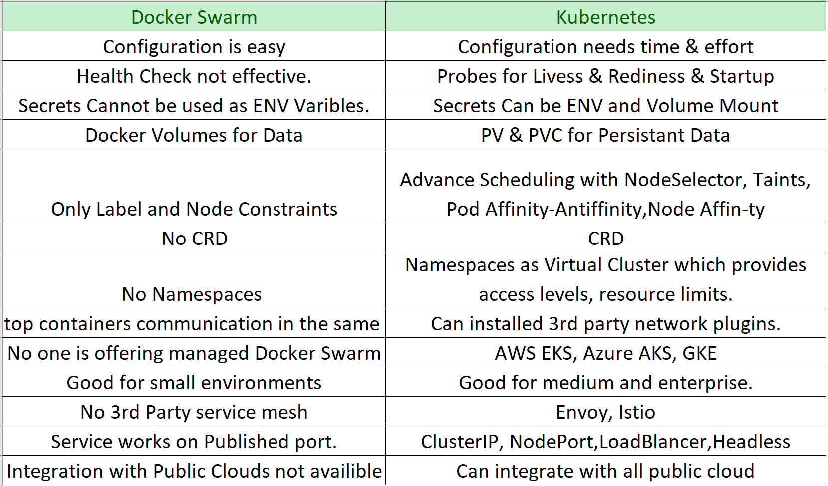

KOPS Kubernetes Installation:

<https://ramhiser.com/post/2018-05-20-setting-up-a-kubernetes-cluster-on-aws-in-5-minutes/>

<https://medium.com/google-cloud/kubernetes-101-pods-nodes-containers-and-clusters-c1509e409e16>

Create DNS Zones & S3 bucket

wget<https://storage.googleapis.com/kubernetes-release/release/v1.11.0/bin/linux/amd64/kubectl>

curl -LO<https://storage.googleapis.com/kubernetes-release/release/$(curl> -s<https://storage.googleapis.com/kubernetes-release/release/stable.txt)/bin/linux/amd64/kubectl>

curl -LO<https://github.com/kubernetes/kops/releases/download/$(curl> -s<https://api.github.com/repos/kubernetes/kops/releases/latest> | grep tag_name | cut -d '"' -f 4)/kops-linux-amd64

chmod +x kops-linux-amd64

chmod +x kubectl

sudo mv kops-linux-amd64 /usr/local/bin/kops

sudo mv kubectl/usr/local/bin/kubectl

ssh-keygen

kops create cluster --name=sreetrainings.xyz --state=s3://sreetrainings.xyz --zones=us-east-1a --node-count=2 --node-size=t2.micro --master-size=t2.micro --dns-zone=sreetrainings.xyz

kops create cluster --name=awscoffeeshop.xyz --state=s3://devopsb13k8sbucket --zones=us-east-1a --node-count=2 --node-size=t2.micro --master-size=t2.micro --dns-zone=awscoffeeshop.xyz --node-volume-size 10 --master-volume-size 20

kops update cluster --name awscoffeeshop.xyz --yes --state s3://devopsb13k8sbucket

export KOPS_STATE_STORE=s3://devopsb13k8sbucket

kops update clustersreetrainings.xyz --yes --state=s3://sreetrainings.xyz

kops delete cluster --namesreetrainings.xyz --state=s3://sreetrainings.xyz

kops delete cluster --namesreetrainings.xyz --state=s3://sreetrainings.xyz --yes